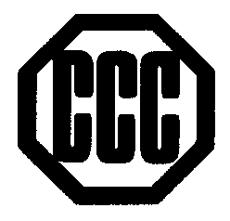
CONSOLIDATED CHEMICAL CO.
ABN 34 527 060 773 ACN 005 056 502

52-62 Waterview Close, DANDENONG SOUTH, 3175
P P.O. BOX 4415, DANDENONG SOUTH, 3164, VIC, AUSTRALIA.
PHONE (03) 8903 3444 FAX (03) 9799 7666
24 hours emergency response: 1800 839 984
E-mail: sales@conchem.com.au
Website: www.conchem.com.au

specification

NUMBER: 20201015

PRODUCT: acetic acid 90% min fg

Item | Unit | Specification
Appearance |  | Clear
APHA Colour |  | 5 max
Freezing Point | °C | Approx. 2
Chloride | ppm | 1 max
Sulphate (as SO₄) | ppm | 1 max
Iron (Fe) | ppm | 0.5 max
Heavy Metal (as Pb) | ppm | 0.5 max
Water | wt% | 10 max
Aldehyde (as CH₃CHO) | ppm | 50 max
Formic Acid | wt% | 0.05 max
Permanganate Time | Hr | 2 min
Purity | wt% | 90 min
Non-Volatile Matter | % | 0.003 max

Country of Origin: South Korea
Shelf Life: 2 years

